LibGuide Training Document V2

Eric Pastore

Spring 2025

Dr. Hannon

CIS 400



Table of Contents

Creating an Editor’s Account/How to Request Changes 2

How Do I Log In? 3

How Do I Add or Change a Profile? 4

How Do I Get to the Data Science Homepage? 5

Types of Change Requests 7

Creating and Editing Pages on the Data Science LibGuide 8

How to Edit the Title of a Page or a Box? 10

How to Reorder a Page or a Box? 11

Other Things You Can Do in the Page Dropdown List 12

Adding or Editing Boxes 13

How to edit the text inside a box? 14

How to add a Section to a Tabbed Box 15

How to Add a Book 17

How to Add a Thumbnail Image of a Book Cover: 18

How to Embed a YouTube video in a LibGuide 19

How to Add a Link or Website to a LibGuide: 22

How to Add a Journal or Article to a LibGuide: 23

How to Add a Dataset or Repository 24

How to add Software Resources 26

Sections That Will Need Frequent Updates 29

Considerations Regarding where Information Should Go 30

Caution About Unsupported Tools or Software 32

How to Check if a Potential Dataset or Repository is Reliable Before Adding it 33

A Few Extra Resources for Updating and Editing LibGuides: 34

## Creating an Editor’s Account/How to Request Changes

* To make changes to the current Data Science LibGuide, you will need administrative access. Typically, only library staff have access to the LibGuide system. You will need to set up an editor's account.
* Contact Ms. Samantha Martin or any library staff member to help you begin this process.
  + Instructional Technology Librarian  
    Washington & Jefferson College  
    Clark Family Library  
    60 S. Lincoln St.  
    Washington, PA 15301
  + 724-503-1001, Ext. 3127
  + [smartin@washjeff.edu](mailto:smartin@washjeff.edu)

## **How Do I Log In?**

Once you have gained administrative access to LibGuides, go to the bottom right corner and find Login to LibApps. Click this link.

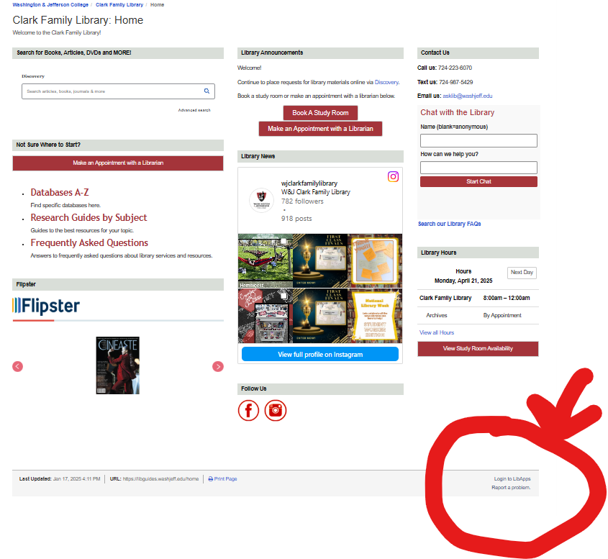

2. Enter your washjeff email into the “email” box.

3. Put your current washjeff password in the “password” box.

4. Once you are logged in, go to LibGuides Home, press the “LibApps” button on the top-left corner and select “LibGuides”. Once you are at the “LibGuides” page, click on the “content” box at the top and choose “Guides.” This will show you the list of LibGuides you are able to access.

5. If you have any additional questions, consider checking out this LibGuide FAQ supported by Springshare: <https://ask.springshare.com/faq/>

## How Do I Add or Change a Profile?

Your Profile Page is a page in LibGuides includes all the information that you enter your Profile Box and gives you the option of adding a personal statement as well.

In LibGuides, your public profile identifies yourself to your audience. Your profile contains a picture, contact information, web links, subject specialties and several avenues of communication. You can manage and update the information displayed in your profile by accessing the My Profile menu option from the LibApps Dashboard.

LibApps Dashboard - Profile  
Your profile box is the box that appears on the LibGuides that you create. By default, your profile box will be added to the first page of any new LibGuide you create, but you can add your profile box to any page of any of your guides.

You can add quite a bit of personal information to your profile box: a picture, contact information, and even social media links and widget.

**To add your profile box, while you are in your editing mode:**

1. Click on the Add Box.

2. On the pop-up page, add a name in the Box name.

3. In the “Type” box click on the drop-down list to select Profile.

4. Then, save your profile.

5. Refresh the page any time you do not see the change

## How Do I Get to the Data Science Homepage?

From the homepage, in the top left corner, you will find a blue box labeled “LibApps.” This will take you to a drop-down menu. Choose the Spring to LibGuides option. This will redirect you to the LibGuides homepage.

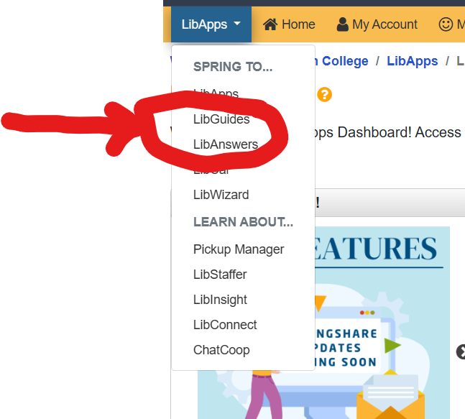  
Find the box labeled Content at the top of the page. It will bring you to a new drop-down menu. Click the “Guides: link.

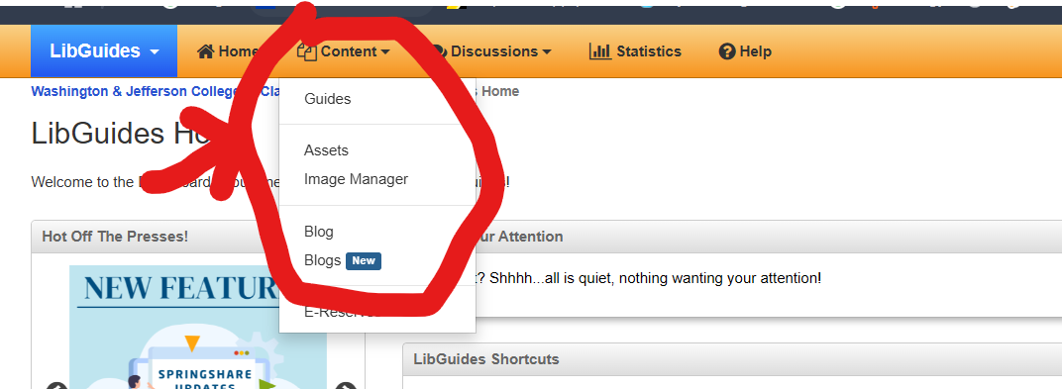

Look for the link that says, “Data Science (DS) Guide”. If your local librarian has granted you access to edit the DS LibGuide, it (the LibGuide) should appear on the list. Click it to be redirected to the Data Science Homepage.

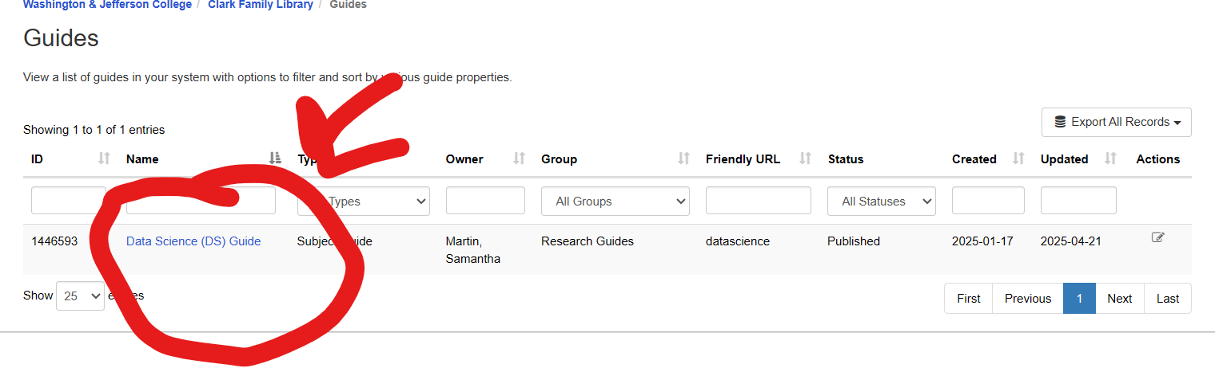  
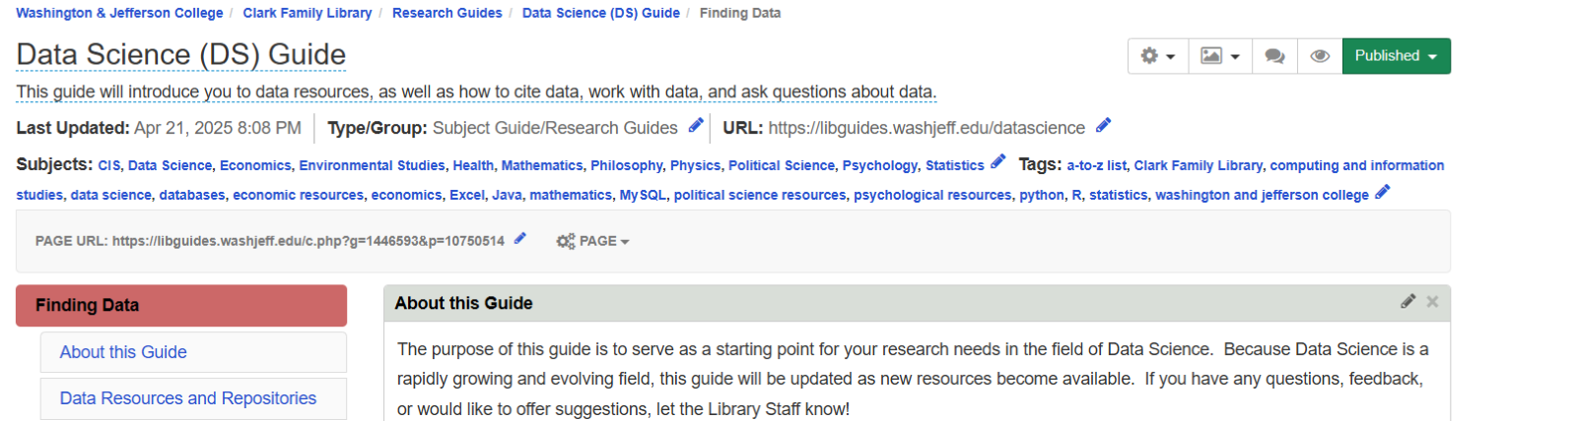

## Types of Change Requests

* Pages
* Boxes
* Tabs
* Books
* YouTube Videos
* Links or Websites
* Articles or Journals
* Data Sets or Data Repositories
* Software Resources
* Online Resources

## Creating and Editing Pages on the Data Science LibGuide

The red boxes are considered “pages.”

Currently, the boxes available on the Data Science LibGuide Page are as follows:

* Finding Data
* Strategies for Working with Data
* Data Science Software Resources
* Books and Articles about DS
* DS Programs and Courses
* Cite Sources
* Get Help

To create a new page, click on the large plus sign below the last/ “lowest” red box (the big red box that is closest to the bottom of the webpage).

* 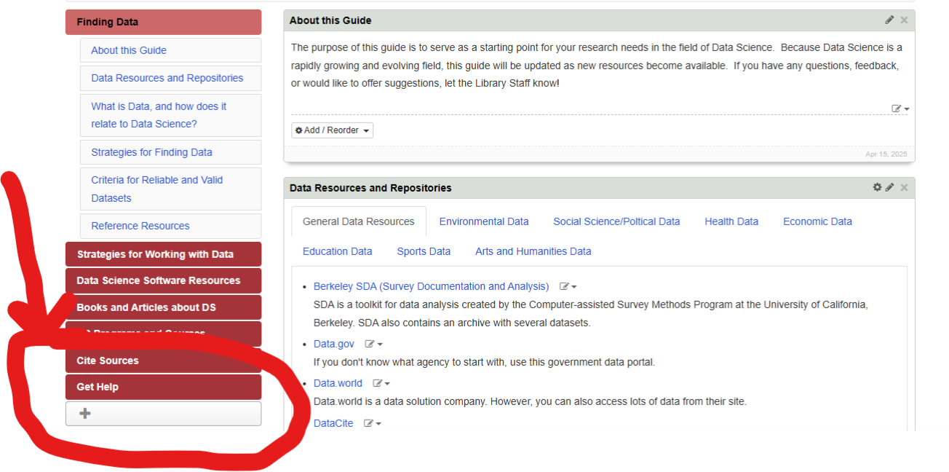  
  Choose which type of page you want this to be:
  + Regular
  + Discussion
  + Blog
* Type in the title of the page under the “Page Name” box.
* Type the description of the page under the “Description” box.
* Decide the position of the page using the “position” box. There are 2 options: a top-level page and a subpage.
* Lastly, decide if you want to show the profile of the LibGuide’s owner or a faculty member using the “Profile Box” box.

## How to Edit the Title of a Page or a Box?

To change the title of a page, click on the gear icon named “PAGE” on the top of the page. On top of the dropdown menu, click on Page Properties. On pop up page, you can change the title of the Page Name.

To edit the title of a box, click on the pencil icon on the right corner of each box

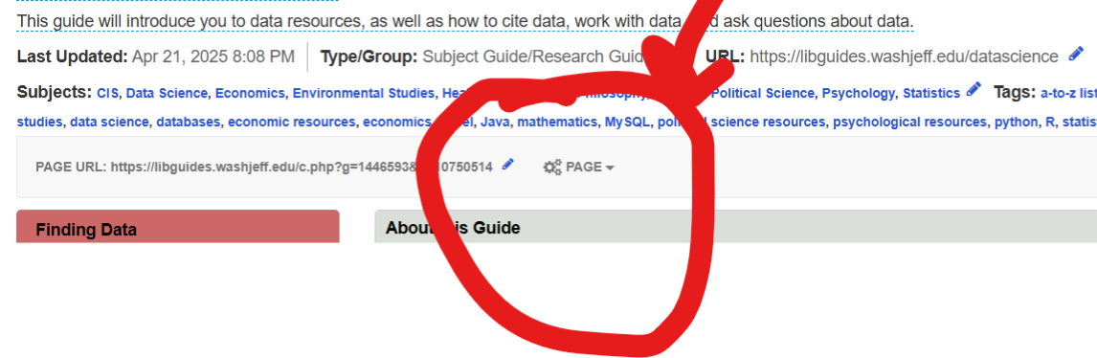

## How to Reorder a Page or a Box?

To change the order of pages, click on dropdown PAGE on the top of the page and move a page to reorder.

To change the order of boxes, click on dropdown PAGE on the top of the page and select the Box and move it to reorder the boxes.

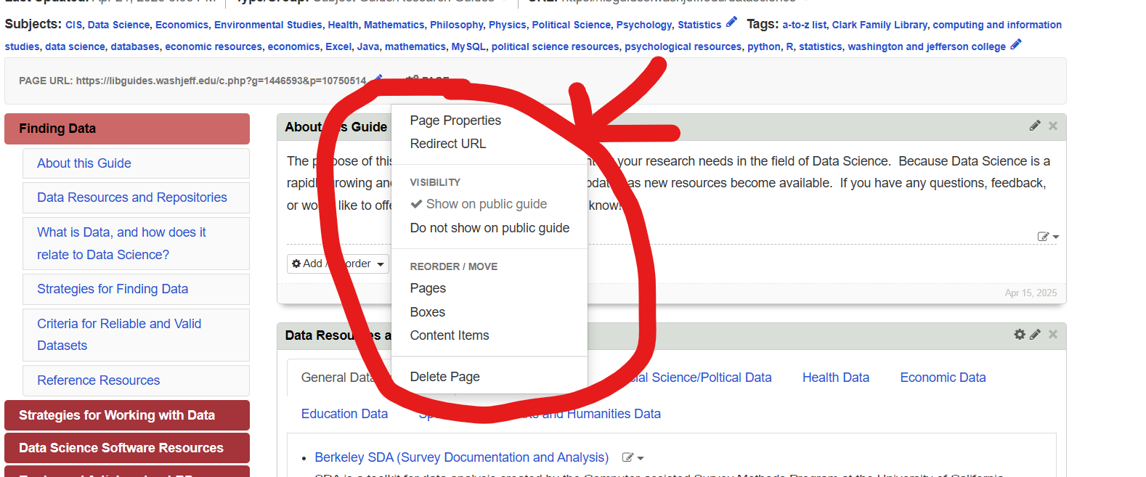  
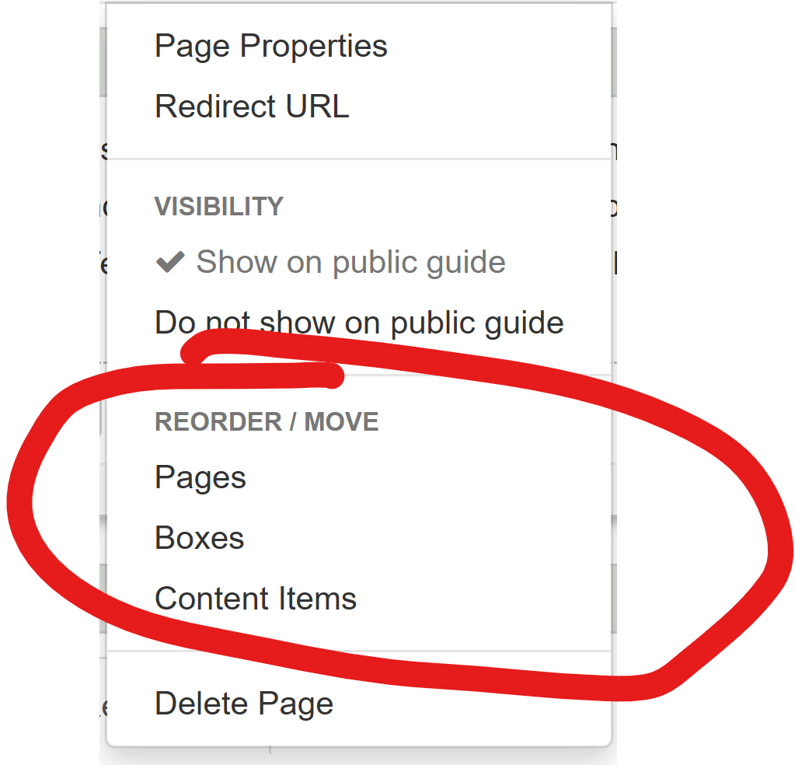

## Other Things You Can Do in the Page Dropdown List

1. You can click on Page Properties to change the title of the page.
2. You can show the page on the public guide or hide it.
3. You can reorder pages and boxes by clicking on the “Pages” or “Boxes” option under the “Reorder/Move” section. To reorder pages and boxes, drag the pages and boxes around after clicking on one of these options.
4. You can click on "Content Items" to reorder the content of the pages by dragging the boxes around in the “Reorder Pages” option.
5. You can delete the page forever. Note that if you delete a page, box, or any form of content, you will lose it permanently! Make sure to only delete pages that are redundant or easy to replace.

## Adding or Editing Boxes

Each “page” has specific “boxes” for additional resources.

To create a new box, go to the bottom of the page and click on the “Add Box” option. You can type the name of the box under the “Box Name” option, choose the type of box you want to add, including a standard, tabbed, gallery, or profile box. Lastly, you can choose the position of this box by clicking on the “position” box.

Note: Once you choose a box type, there is no simple way to change it back. In other words, if you want to change a box type, you will have to create a new box with the type you want that includes the same title, move each of the elements in the old box into the new one, and delete the old box when you are done moving the elements.

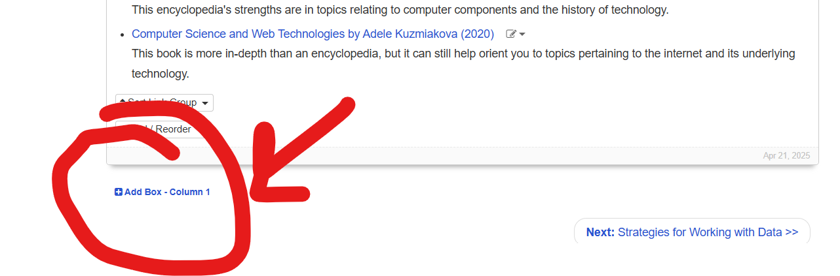

## How to edit the text inside a box?

To edit a text inside a box, click on square with a pencil button. It will allow you to bring any changes you want in the text inside that box, including the option to edit the text directly, as well as using html code.

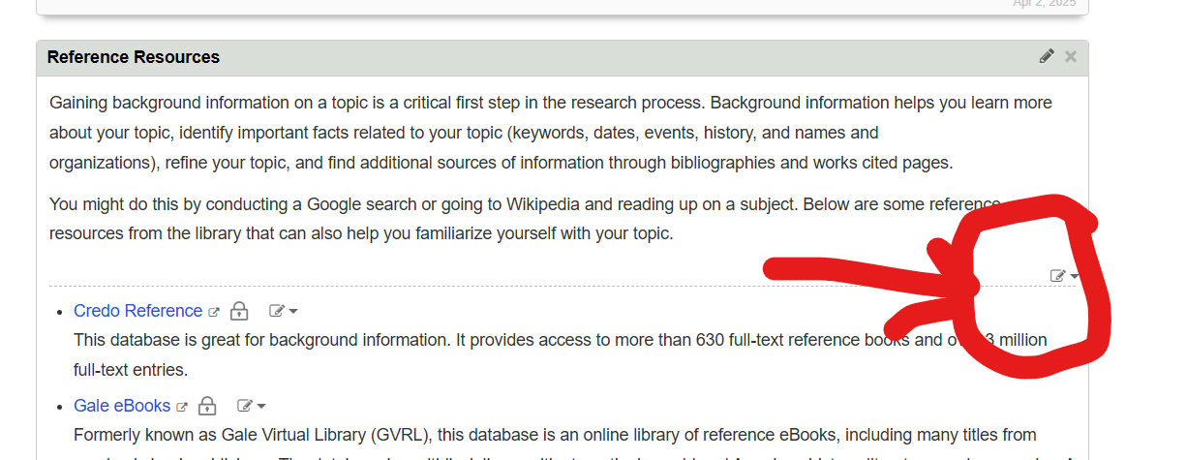

## How to add a Section to a Tabbed Box

To add a new section to a tabbed box (e.g. the “Data Resources and Repositories” and “Programming for Data Science” Boxes), click on the cog next to the pencil on the top right of the tabbed boxes.

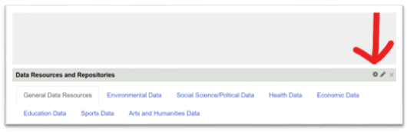

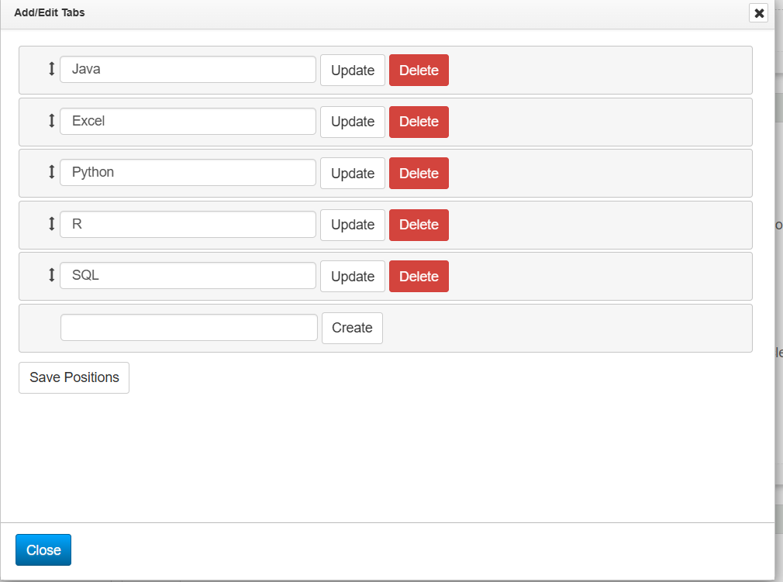

Type the name of your new tab in the bottom-most empty box. Once you are done typing, click “Create”. To add new resources, click on the add/reorder box. Choose the type of link you are adding, add the resource, item details and descriptors. Be sure to save your work when you are done.

## How to Add a Book

Click on Add / Reorder. Then, on the dropdown list click on Book from the Catalog and complete the pop-up form and save. You can also type in the book’s ISBN number in the “ISBN” box to instantly add a book to the LibGuide! Note: If the Library does not contain a specific book, you will need to enter the data of the book manually.

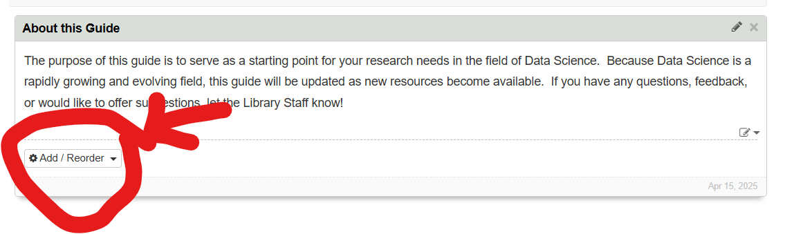  
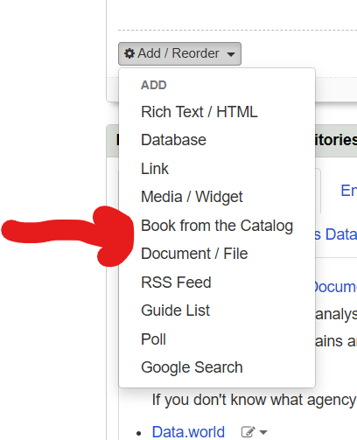

## **How to Add a Thumbnail Image of a Book Cover:**

Take a picture of a book cover, save it on the desktop. Open the LibGuide, click on Image Manager under the Content tab. Click on the "Upload a New Image" button which is the green button. Bring the image from the desktop or another place you saved the image. Find it from among bellow copied images and click on the link sign, copy the link, and paste it in the proper field in the Add/Edit Content where you want to add the cover image.

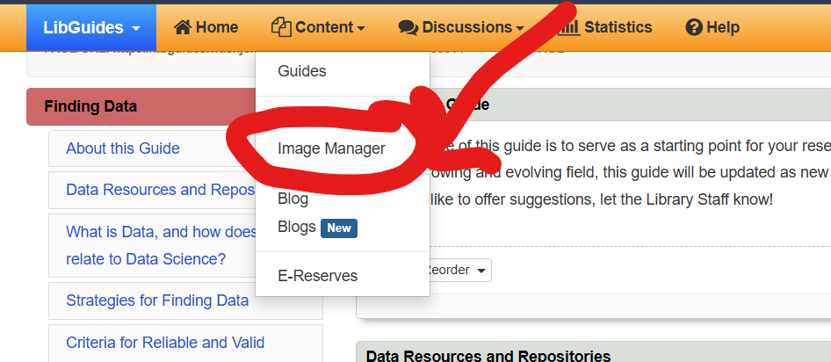  
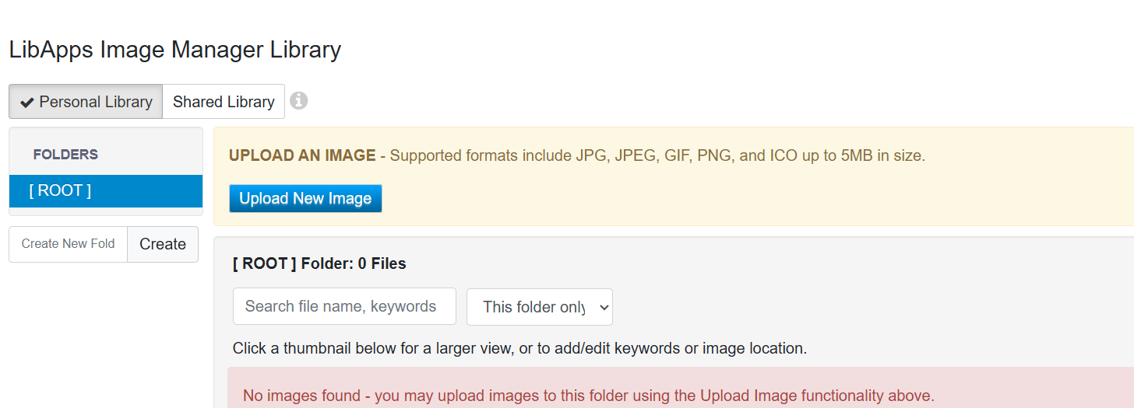

## How to Embed a YouTube video in a LibGuide

1. Under your desired YouTube video, click on “Share” button.

2. Then, click on the “Embed” button on the left side of the box.

3. Copy the code from the box titled “Embed Video”.

4. Go to your guide and on the “Add / Reorder” dropdown menu, click on the “Media / Widget” option and paste the code from the “Embed Video” box there.

5. Lastly, save your changes.

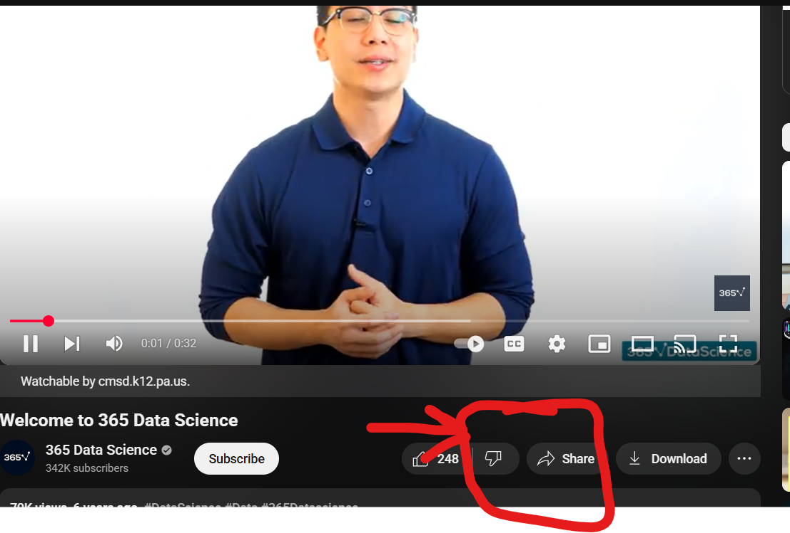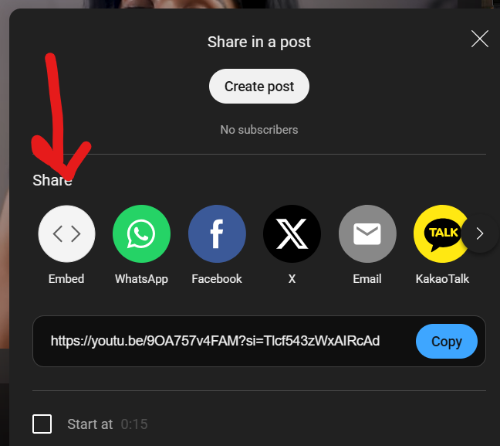

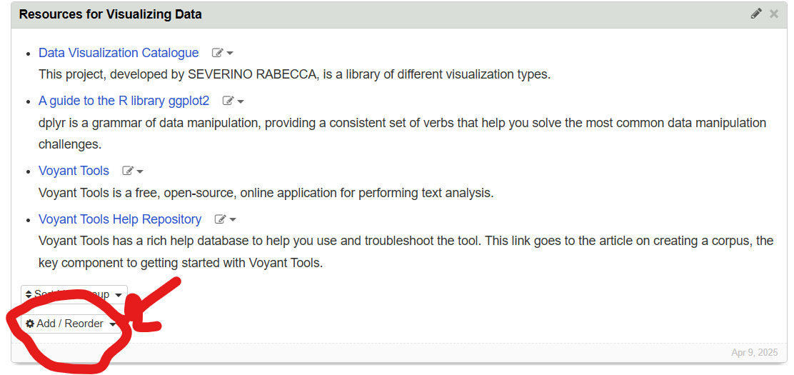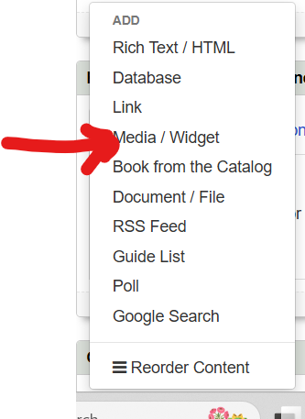

## How to Add a Link or Website to a LibGuide:

Click on the “Add/Reorder” button. In the dropdown menu, click on “link” and then add the information about the desired website. This can include the link itself, its name, and its description. Make sure to position the links in alphabetical order. Note: If any of the links in the box are not in alphabetical order, click on the “Sort Link Group Button” and select “By Title” as the “Sort Type.”. If a link is broken or takes you to a list of pages that are broken, make sure to delete and/or replace it with a link that contains similar information.

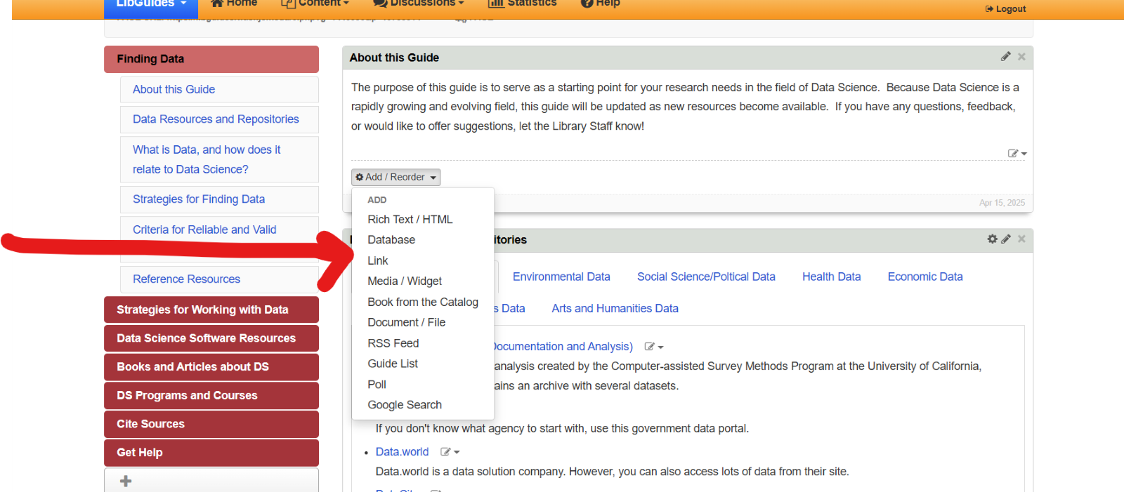

## How to Add a Journal or Article to a LibGuide:

Go to the Books and Articles Page on the Data Science LibGuide.

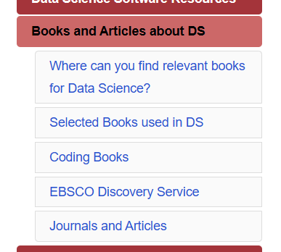

Go to the Journals and Articles Box.

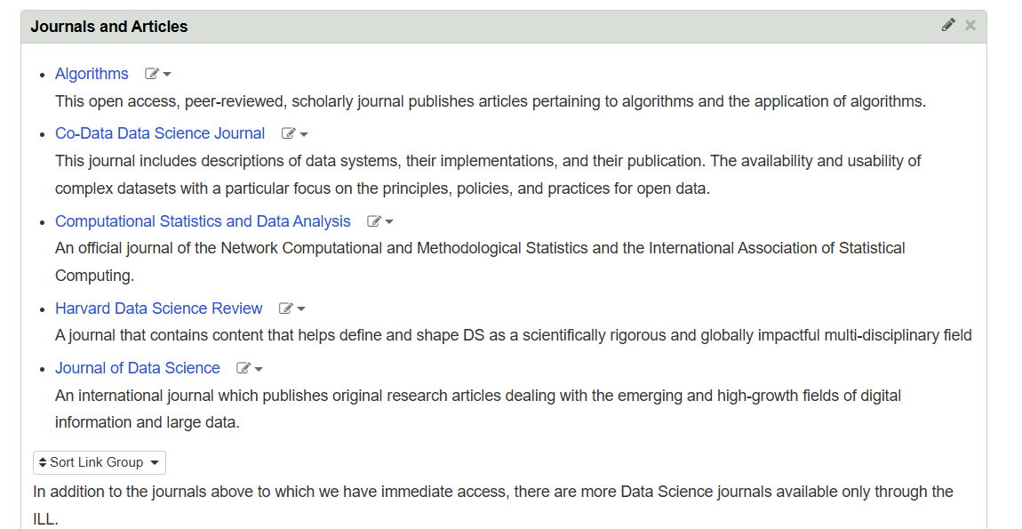

Click on the “Add/Reorder” button. In the dropdown menu, click on “link” and then add the information about the desired website. This can include the link itself, its name, and its description. Make sure to position the links in alphabetical order. Note: If any of the links in the box are not in alphabetical order, click on the “Sort Link Group Button” and select “By Title” as the “Sort Type.”. If a link is broken or takes you to a list of pages that are broken, make sure to delete and/or replace it with a link that contains similar information.

## How to Add a Dataset or Repository

Data Resources and Repositories are found under the “Finding Data Page”.

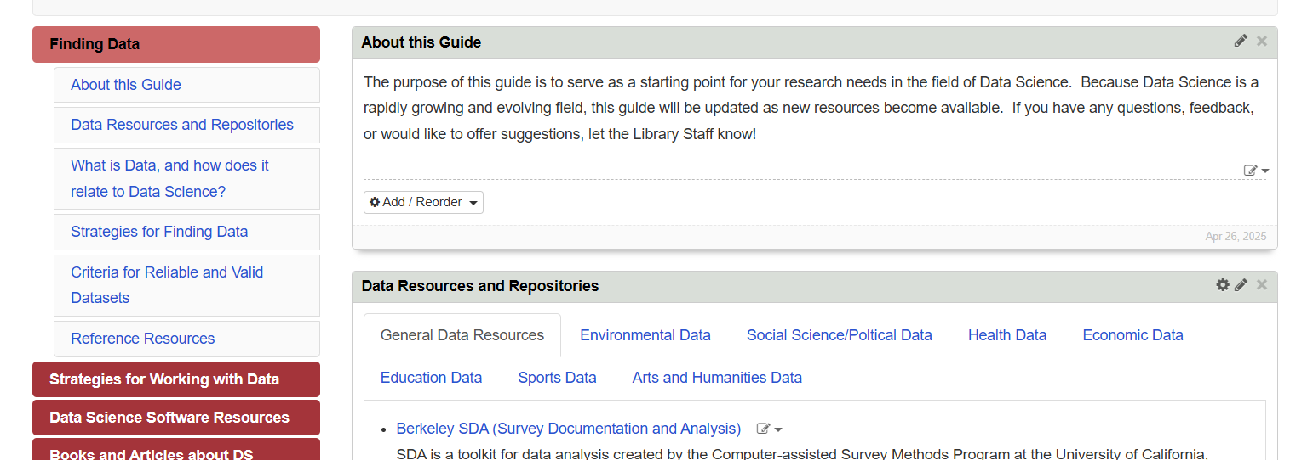

Before adding a new repository or similar information, be sure to determine which category it belongs to. The current categories are as follows:

* General Data Resources
* Environmental Data
* Social Science/Political Data
* Economic Data
* Education Data
* Sports Data
* Arts and Humanities Data

If you are unsure of which category the data repository falls under, consider speaking with your librarian or faculty member that teaches a related course. If you are still unsure, you can add another category by following the steps located under the “How to add a Section to a Tabbed Box” tutorial.

Note: A Dataset or Repository can come in many forms, such as a .csv file, an .xml file, a spreadsheet, a .json file, a .zip file, and many more forms. Be sure to consider these forms before adding a Data Repository to the LibGuide. If you have any questions, consult Dr. Ladd, Dr. Rapp or your local librarian for additional advice.

## How to add Software Resources

Software resources are found on the Data Science Software Resources page.

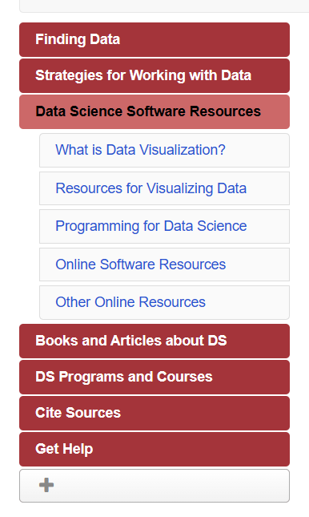  
Before adding new software resources, be sure to determine which category it belongs to. The current programming software resources are as follows:

* Java
* Excel
* Python
* R
* SQL

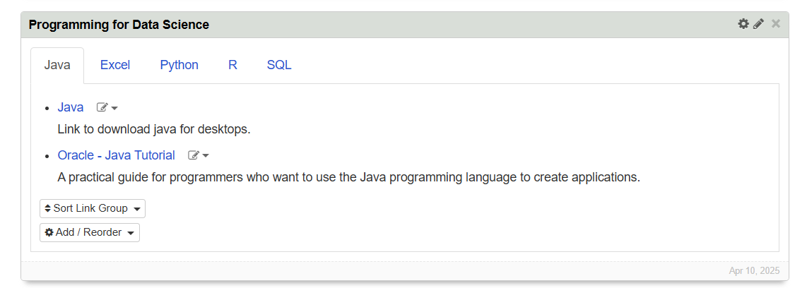

To add another resource to a programming section, such as Java, click on the “Add/Reorder” Box, then click on the type of item you want to add from the dropdown menu. Then, add your resources, item details and description. Be sure to save your work.

If you wish to add another section to the tabs, follow the steps located in the “How to add a Section to a Tabbed Box” tutorial.

Another box of software resources is the Online Software Resources.

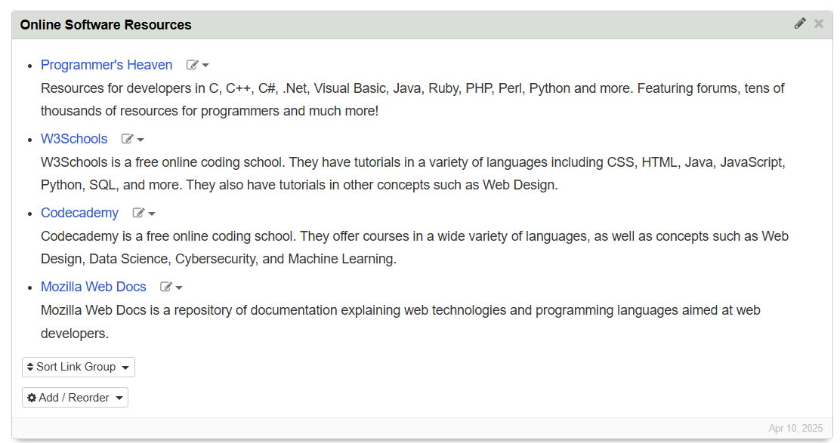

To add another resource to this section, click on the “add/reorder” box. Choose which type of resource you are adding. Add your new resource, item details and descriptors. Be sure to save your work when you are done.

The final section on this page is “Other Online Resources.”

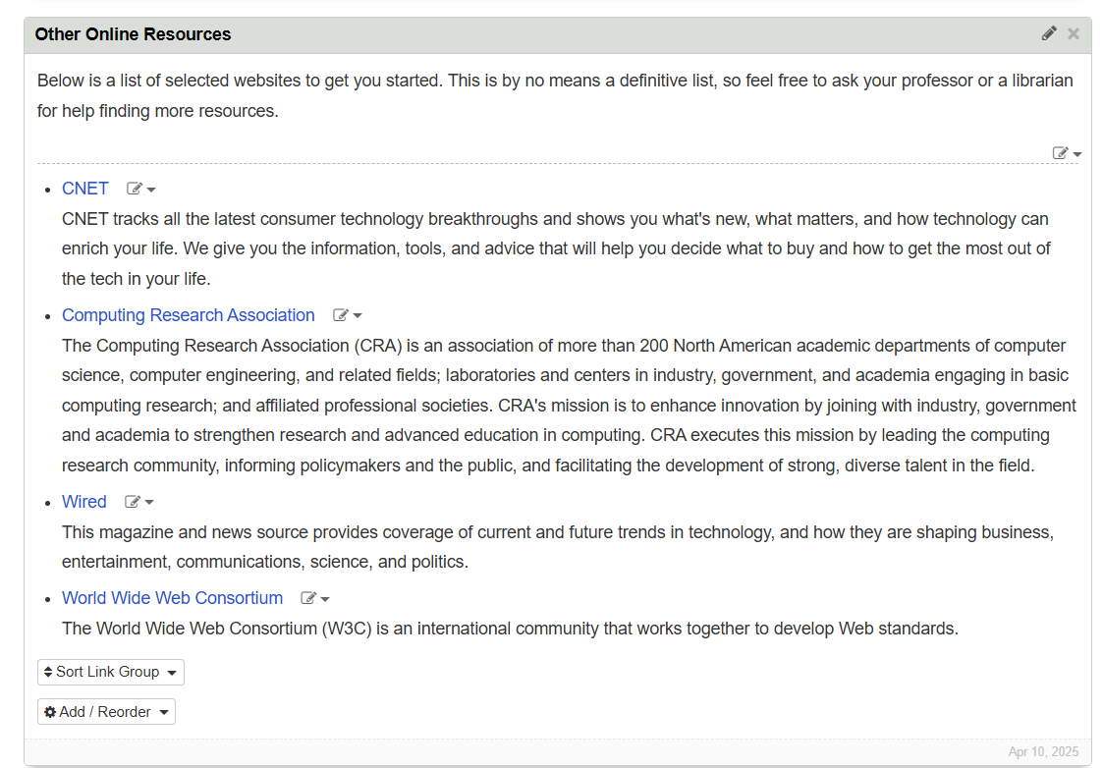  
To add another resource to this page, click on the add/reorder box. Choose which type of resource you are adding. Add your resource(s), item details and descriptors. Be sure to save your work when you are done.

## Sections That Will Need Frequent Updates

The following sections will need the most attention to updating.

* Data Sources and Repositories
  + Consult with Dr. Ladd, Dr. Rapp and other faculty members who teach courses related to Data Science for their input.
  + Consider consulting with faculty every semester, as courses and resources can change frequently
  + Also consider discussing any changes with library staff as they may have more information about data sources and repositories
* Resources for Visualizing Data
  + Consult with Dr. Ladd, Dr. Rapp or any other faculty member within the CIS/Data Science Department for guidance or updates.
* Programming for Data Science
  + While this resource may not change frequently, new resources may become available.
  + Consult with Dr. Ladd, Dr. Rapp and any other faculty member within the CIS/Data Science Department for guidance and updates
* Online Software Resources
  + While this resource may not change frequently, new resources may become available and/or old resources may be eliminated.
  + Consult with Dr. Ladd, Dr. Rapp and any other faculty member within the CIS/Data Science Department for guidance and updates.
* Selected Books Used for Data Science
  + This resource MAY change based on faculty members teaching courses related to Data Science.
  + Consult faculty members on a semester basis to determine their needs. Resources may need to be added or eliminated based on curriculum.
* Journals and Articles
  + This resource MAY change based on faculty members teaching courses related to Data Science.
  + Consult faculty members on a semester basis to determine their needs. Resources may need to be added or eliminated based on curriculum.

## Considerations Regarding where Information Should Go

Currently, there are 6 major categories of information organized on separate “pages”.

* Finding Data
  + About the Guide
  + Data Resources and Repositories
  + What is Data, and how does it relate to Data Science?
  + Strategies for Finding Data
  + Criteria for Reliable and Valid Datasets
  + Reference Resources
* Strategies for Finding Data
  + Researching Data
  + Evaluation Data
  + Developing Keywords
* Data Science Software Resources
  + What is Data Visualization
  + Resources for Visualizing Data
  + Programming for Data Science
  + Online Software Resources
  + Other Online Resources
* Books and Articles About Data Science
  + Where Can You Find Relevant Books for Data Science
  + Selected Books Used in Data Science
  + Coding Books
  + Ebsco Discovery
  + Journals and Articles
  + Interlibrary Loan
* Data Science Programs and Courses
  + Data Science Minor FAQ
  + Experimental Philosophy
* Cite Sources
  + Why Do We Cite
  + How to Cite
  + Attributing and Citing Code
  + Citation Styles
* Get Help
  + Contact Us
  + Related Guide(s)
* To determine which category a particular resource belongs, consult with faculty members who teach courses related to Data Science for their guidance.
  + For example: Data Repositories related to Health and Science belong in the Health and Science Data Repositories; whereas a new journal or article belongs under Books > Journals > Articles.
  + If a Data Repository does not fall under any category, a new box must be created based on the repository’s subject.
    - For Example, Data Repositories related to Physics require a “Physics” Tab in the “Data Resources and Repositories” Box to be created.

## Caution About Unsupported Tools or Software

* It is crucial to verify that all tools and software used with a dataset are supported by ITS and CIS. Unsupported software can introduce significant security risks, and it's essential to ensure that all software is properly patched and maintained.
* Why is this important? It is crucial to verify that all tools and software used with a dataset are supported by ITS and CIS. Unsupported software can introduce significant security risks, and it's essential to ensure that all software is properly patched and maintained
* **Security Vulnerabilities:**
  + Unsupported software often has known vulnerabilities that are no longer being patched by the vendor. This can create opportunities for attackers to exploit these vulnerabilities and gain access to sensitive data.
* **Compliance Issues:**
  + Using unsupported software may violate compliance standards and regulations that require organizations to maintain up-to-date software and security patches.
* **Compatibility Problems:**
  + Unsupported software may not be compatible with current systems and infrastructure, leading to compatibility issues, performance problems, and even downtime.
* **Data Loss:**
  + Unsupported software may not integrate well with data backup solutions, potentially leading to data loss or corruption.

## **How to Check if a Potential Dataset or Repository is Reliable Before Adding it**

* 1. Evaluate the source: Who created the data and why? Look for reputable sources like government agencies, academic institutions, or well-established research organizations. If available, check the author's institutional affiliation and any associated publication. Determine if the dataset or repository has been peer-reviewed or vetted by experts.
  2. Verify the accuracy of the data. Where and when was the data collected? Is this data still accurate or relevant? Ensure the dataset includes all necessary variables and fields. Compare the data with reliable sources or conduct validation checks. Remove inconsistencies and preprocess the data before use, especially for AI training
  3. Consider: Is the link harmful to users’ devices? If not, who can use the data? What formats of downloads are available? (.csv, .txt, .json, etc.)
  4. Also, evaluate its metadata requirements, persistent identifier (like DOI), access restrictions, and licensing terms. A trustworthy repository should also provide clear guidance on how to cite the data and track usage statistics.

## A Few Extra Resources for Updating and Editing LibGuides:

[LibGuide Webinar](https://higherlogicdownload.s3.amazonaws.com/SLA/275b1c44-ef92-4ce3-b29e-342ccb6035a8/UploadedImages/GMT20220421-180324_Recording_1920x900.mp4)

[LibGuide Tutorial](https://campusguides.lib.utah.edu/c.php?g=1133118&p=8813316)

[Embedding a Video to a LibGuide](https://www.youtube.com/watch?v=UFeg3Mj81f8&embeds_referring_euri=https%3A%2F%2Fcampusguides.lib.utah.edu%2F&source_ve_path=MjM4NTE)

Note: Refresh the page any time you don’t see a change occur.